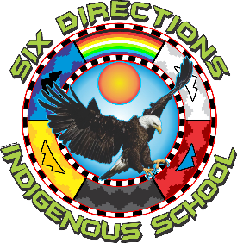

https://lh4.googleusercontent.com/0eIbwl32weN3WVv7suFRRtLPVM-Jo8KpwU0sCqjJrWgSdGHqcQ5lDsJH67gihnLFlu0a_JOUk84TMw1dPpNLqGy1iU7yLTpIPv9DiViiDJYBmSGy4SDOTPzlfkFsYYsuUdOmZvJZ2PaWTXcN7GXonvg

**2055 NM-602**

**Gallup, NM 87301**

**Phone:  505-863-1900  Fax:  505-863-8826**

Governing Council Regular Meeting Agenda  
April 29, 2025

Six Directions Indigenous School Student Council Room  
 5:30 PM

<https://zoom.us/j/92637165891?pwd=A44b66SAew2a1KWJMZM5FZCbqI9L78.1>

Meeting ID: 926 3716 5891

Passcode: SDIS

● Opening/Greetings:  
 Each governing council member introduces themselves for attendance.

● Land Acknowledgement:  
 Honoring the land and peoples of this region.

● Public Comment:

I. Introduction of Agenda Items

A. Approval of Previous Meeting Minutes (March 25, 2025)  
B. Approval of Current Meeting Agenda

## II. Action Items

A. Approval of Budget Adjustment Requests (BARS)

* 568-000-2425-0027-IB
* 568-000-2425-0029-I
* 568-000-2425-0030-T
* 568-000-2425-0031-I

B. Approval of Operational Budget Review Presentation (Aaron Savoia, Vigil Group)

* Acceptance of FY25 Operational Budget

## III. Presentation Items

A. FY25 Operational Budget Presentation

* Aaron Savoia, Vigil Group

B. Charter School Division Site Visit Preparation (Scheduled for April 30, 2025)

* Review of expectations, materials, and timeline.

## IV. Discussion Items

A. Introduction of Possible Board Members - Ky George

B. Head Administrator Evaluation Update  
C. Spring Budget Attendees Share Out  
D. Strategic Planning and PEC Microgrant Update (Including Retreat Planning and Self-Evaluation)

E. Upcoming Events and Community Engagement (Optional addition if needed)

## V. Information Items

A. Head Administrator Report

VI. Conclude Business

* Note End Time