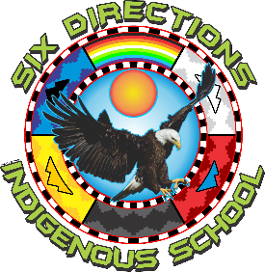
2055 NM-602
Gallup, NM 87301
Phone: 505-863-1900 Fax: 505-863-8826

Finance Committee Meeting Notice & Agenda
Date: August 26, 2025
Time: 5:30 pm
Location: SDIS Office / Zoom Link: https://zoom.us/j/96995430065?pwd=uQxyGbWFkKUjMcQy4TGD7ClrTbjIuK.1
Passcode: finance

Notice
The Finance Committee of the Six Directions Indigenous School Governing Council will hold a meeting as indicated above. This meeting is open to the public in accordance with the Open Meetings Act.
Agenda
- Financial Reports - Presented by Aaron Savoia
  - Budget Status Report
  - Bank Reconciliation
  - Expenditure Reports
- Budget Adjustment Requests (BARs)
- Grant & Funding Updates

