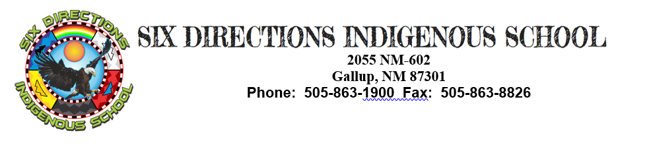

Job Description

The Six Directions Indigenous School, through a commitment to culturally relevant indigenous education and interdisciplinary project-based learning, will develop critically conscious students who are engaged in their communities, demonstrate holistic well-being, and have a personal plan for succeeding in post-secondary opportunities.
Job Title: Health & Physical Education Teacher Supervisor: Rebecca Niiha

Job Summary
Position is responsible for creating a classroom environment that fosters, promotes and develops an understanding of Indigenous Wellness; celebrates the identities of SDIS students; correlates to the histories, stories, and dispositions of Indigenous People and Cultures; creates spaces inclusive of the relationship of healthy body function and exercise; that motivates each student to cultivate physical fitness, and appropriate social and emotional adjustment; that discovers and develop talents of students in physical achievement; and that develops strength, skill, agility, poise, and coordination in individual, dual and team physical activities and sports, in accordance with each student’s ability.

Essential Duties
- Teaches knowledge and skills in physical fitness, health education, rhythms and dance, and individual, dual or team sports, utilizing curriculum designated by Six Directions Indigenous School and other appropriate learning activities.
- Works cooperatively with other physical education teachers in planning and implementing a balanced physical education program.
- Analyzes, demonstrates, and explains basic skills, knowledge and strategies of formal sports, games, rhythms, and fundamentals of body movement.
- Develops lesson plans and supplementary materials compatible with the division’s basic instructional philosophy and congruent with course and SOL standards; provides individualized and small group instruction in order to adapt the curriculum to the needs of each student and subgroups of students.
- Establishes and maintains standards of student behavior to provide an orderly, productive environment in the physical education areas.
- Provides appropriate safety instruction and makes safety checks on equipment and field areas to ensure the overall safety of students.
- Evaluates academic and social growth of students, prepares report cards, and keeps appropriate records to include attendance reports, checklists, census forms, and other recordkeeping activities as necessary.
- Maintains control of storage and use of school property.
- Evaluates each student’s growth in physical skills, knowledge and contribution in team sports.
- Communicates with parents and school counselors on student progress.
- Supervises students in out of classroom activities during the assigned working day.
- Administers testing in accordance with division testing practices.
- Models nondiscriminatory practices in all activities.

(These are intended only as illustrations of the various types of work performed. The omission of specific duties does not exclude them from the position if the work is similar, related, or a logical assignment to the position.)

Other Duties
- Maintains professional competence by attending staff development programs, curriculum development meetings and other professional activities.
- Participates in various student and parent activities which occur in school including PTA, student clubs and after-school activities.
- Creates an effective learning environment through functional and attractive displays, bulletin boards, and activity/learning centers.
- Performs any other related duties as assigned by the Head Administrator.

Job Specifications
To perform this job successfully, an individual must be able to perform each essential duty satisfactorily. The requirements listed below are representative of the knowledge, skill and/or ability required. Reasonable accommodation may be made to enable individuals with disabilities, who are otherwise qualified, to perform the essential functions.

Minimum Qualifications (Knowledge, Skills and/or Abilities Required)
Must possess a Bachelor’s or Master’s degree in education or a related field and meet the New Mexico Department of Education licensure eligibility requirements to teach physical education. Must be eligible for, or in possession or an appropriate New Mexico teaching license. Must possess ability to communicate effectively verbally and in writing. Must possess the ability to establish and maintain effective working relationships with students, staff, parents, and the public.

Working Conditions and Physical Requirements
The physical demands described here are representative of those that must be met by an employee to successfully perform the essential functions of this job. Reasonable accommodation may be made to enable individuals with disabilities to perform essential functions.
Must have the ability to sit and stand for extended periods of time; exhibit manual dexterity to dial a telephone, to enter data into a computer; to see and read a computer screen and printed material with or without vision aids; hear and understand speech at normal classroom levels, outdoors and on the telephone; speak in audible tones so that others may understand clearly in normal classrooms, outdoors and on the telephone; physical agility to lift up to 25 pounds to shoulder height and 50 pounds to waist height; and to bend, stoop, sit on the floor, climb stairs, walk and reach overhead.

Work Environment
The work environment characteristics described here are representative of those an employee encounters while performing the essential functions of this job. Reasonable accommodations may be made to enable individuals with disabilities to perform the essential functions. Duties are normally performed in a school/classroom environment. Duties may be occasionally performed on field trips away from school. The noise level in the work environment is usually moderate.

Supervision Exercised: May include instructional assistants, volunteers, tutors.
Supervision Received: Head Administrator

This job description in no way states or implies that these are the only duties to be performed by this employee. The Teacher will be required to follow any other instructions and to perform any other related duties as assigned by the Principal or appropriate administrator. Six Directions Indigenous School reserves the right to update, revise or change this job description and related duties at any time.

I acknowledge that I have received and read this job description.

Employee Name (Print) Signature Date

