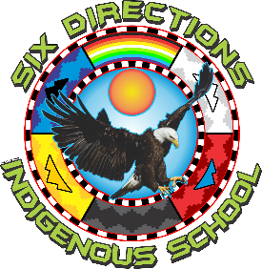
2055 NM-602
Gallup, NM 87301
Phone: 505-863-1900 Fax: 505-863-8826

Six Directions Indigenous School Governing Council Regular Meeting Agenda
At Six Directions Indigenous School, we are committed to culturally relevant Indigenous education and interdisciplinary project-based learning. Our mission is to develop critically conscious students who are engaged in their communities, demonstrate holistic well-being, and graduate with a personal plan for post-secondary success.
Date: Tuesday, August 26, 2025
Time: 5:30 pm
Location: Six Directions Indigenous School Student Council Room
Zoom link: https://zoom.us/meetings/91028510532/invitations?signature=rnK2it9ctp0N7U9Xpe_uQ2Rn2uQEBvQQJUywK5XxqUc
Password: SDIS2025
- Call to Order
- Roll Call / Establish Quorum
- Opening Reflection / Land Acknowledgment
- Approval of Agenda
- Approval of Prior Meeting Minutes
- Public Comment

Discussion & Action Items
- Approval of Financials (BARs, requisitions, contracts, etc.)
  - 568-000-2526-0001-M
  - 568-000-2526-0002-T
- Approval of Chapter Resolution for Capital Outlay Application & Facilities
- Policy Review / Updates (attendance, staff expectations, student handbook changes if any)
  - Approval of Staff Policies & Procedures
  - Approval of Student Handbook
  - Approval of Cell Phone Policy
- Strategic Planning Updates (schoolwide interdisciplinary curriculum, professional development calendar, etc.)
Committee Reports (if any)
  - Governance / Policy
  - Facilities / Capital Outlay
  - Community Engagement
Head Administrator Report
  - Enrollment update
  - Academic and cultural programming highlights
  - Staffing updates (new hires, vacancies)
  - Grants and funding updates (Wellness Room, Indian Ed, Math Lab, etc.)
  - Compliance and site visit feedback

Closing
Adjournment

